Last Updated: 9/1/2021
Jump Links: Access SuccessFactors, Updating Position Details
This QRG outlines the steps required to update the details of a position. Common edits include updating supervisor and work location status FTE or other changes often made before filling vacant position.

When to Update Position Details
The main instance in which position details should be updated is when the position is vacant and needs data elements to be changed prior to posting.
Exceptions:
- Updates to a position’s higher-level position (supervisor) may be made via Updating Position Details whether the position is vacant or filled.
  - Note: When a supervisor is terminated, the termination initiator will be presented with the opportunity to re-assign all direct reports (individually or en masse) to an interim person or position– it is not necessary to follow the steps in this QRG to re-assign direct reports of a supervisor being terminated.
- Updates to a mass position’s title should be made using the steps included in this QRG
When a position is currently filled, changes to the position (other than supervisor or title for mass positions) should occur through an employee data change.

Position Detail Update Process
The Initiator receives a request to update the supervisor of a position, update the title of a mass position, change a data element of a vacant position, or delimit a position and processes it in SuccessFactors. Once complete, it is routed to HR Admin-Position via the workflow process for either approval or rejection.

Access SuccessFactors
Visit OneCampus and select Employee Launchpad or from the Employee Self-Service web page click SuccessFactors  Log in using Purdue Career Account ID and Password. | https://one.purdue.edu/  https://www.purdue.edu/hr/global/pgnew.php  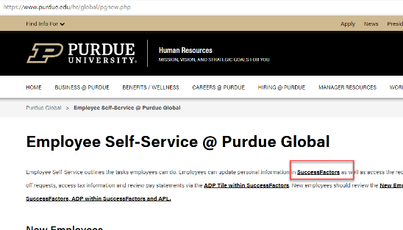

Updating Position Details
Using the Home drop-down menu, choose Company Info | 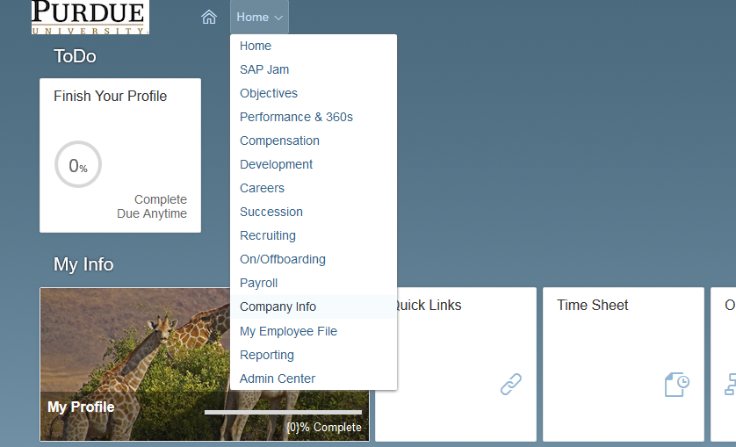
On the Company Info screen,
Click Position Org Chart
Select the desired Search By option.  (By position or by person) | 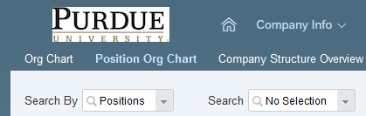  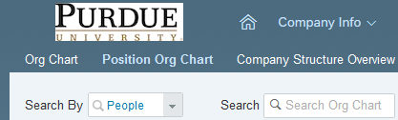
Depending on the Search By option selected, Enter the Position Number or Person’s name into the Search field
The org chart will appear.  If direct reports exist, they will populate below the position box | 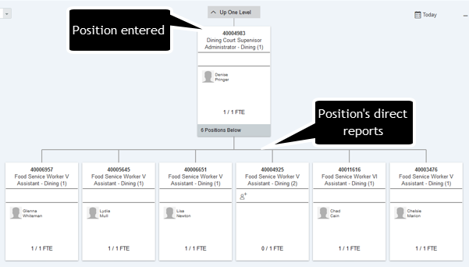
To update the position details, click inside the position box | 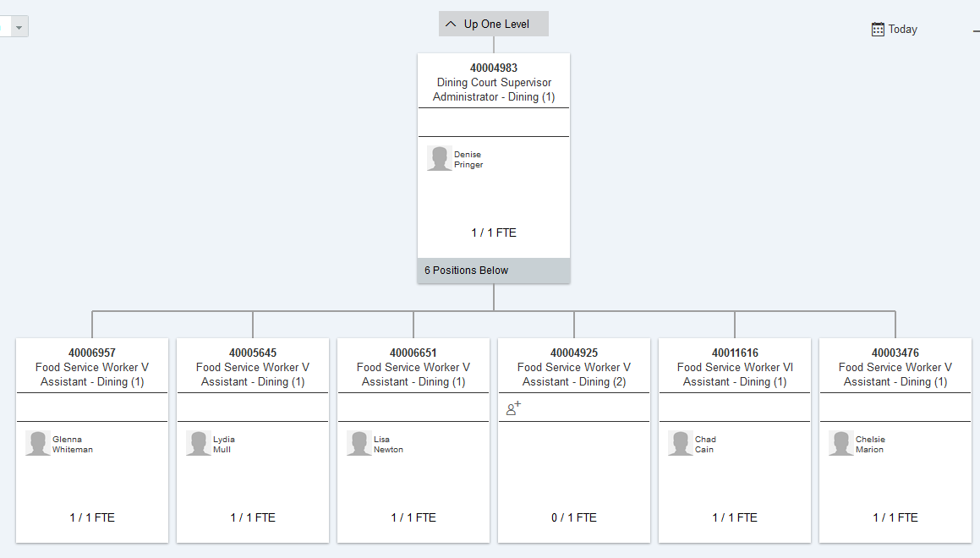
Pop-up box will appear to the right of the position; click on the Show Position icon. | 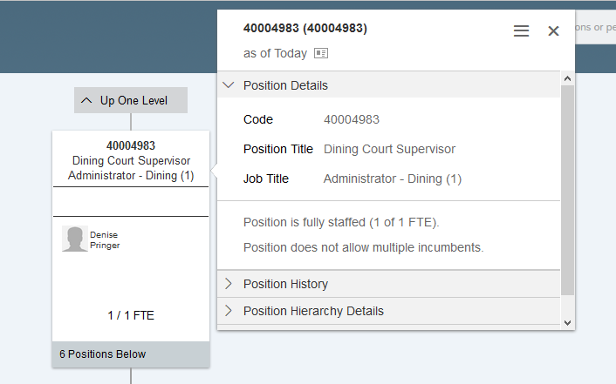
Position box will appear.  Click Edit. | 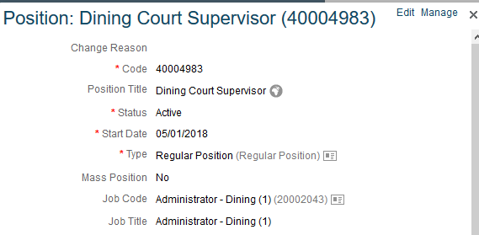
Enter Effective Date in the pop-up box.  Click Proceed. | 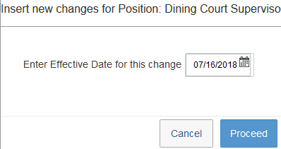
Position data entry screen will appear.  Edit data as necessary.  For guidance and definitions regarding each of the fields and tips for completing them, please see the Purdue Global Position Field Overview guide.  TIPS  - Higher-Level Position field designates the position’s supervisor.  - Use Type and FTE fields to adjust to/from Mass Positions.  - Ensure To be Hired field is marked if appropriate.  Scroll down to view all available fields.  Select the appropriate Location Group - Purdue Global (PG)  Select the appropriate Location:  - PG – Remote if employee is working remotely  - PG – WL if the employee is working onsite at the West Lafayette campus.  Select the appropriate Location Status  - Remote – 100%: majority of work is done on a computer and collaboration can occur virtually through email, phone, text, instant messaging, and/or video conference; work is performed independently and does not require a high level of manager oversight.  - Please note when the position is filled this field should be updated with Remote – State from the picklist.  - Hybrid/Rotational: job is capable of remote work, but may require some on-site work days to accomplish tasks that cannot be performed while remote (choose option that most closely represents ongoing schedule for the position); on-site = West Lafayette campus  - Hybrid (Remote) 25% - (On-Site) 75%  - Hybrid 50/50  - Hybrid (Remote) 75% - (On-Site) 25%  - On-Site – 100%: job requires a physical presence to perform the work; job duties may require the use of equipment, dedicated work space, service, delivery, or public safety; manager oversight is often required; on-site = West Lafayette campus  Select the appropriate Essential Worker Status  - Essential: Position a department has deemed critical and necessary to keep the core operations and infrastructure running on a bare minimum level.  Once all updates are complete, click Save.  Click Save when all edits are complete. | 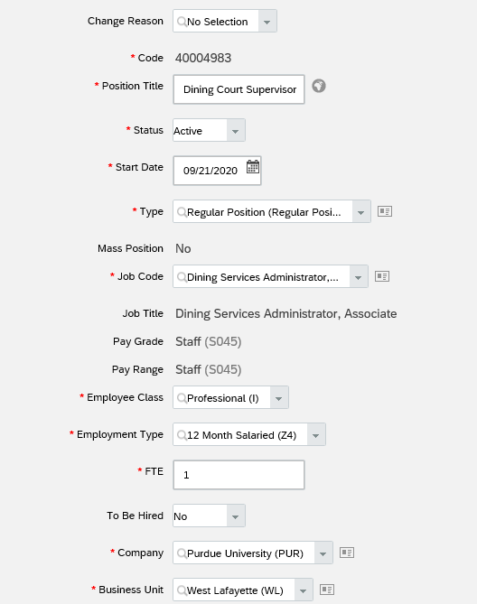  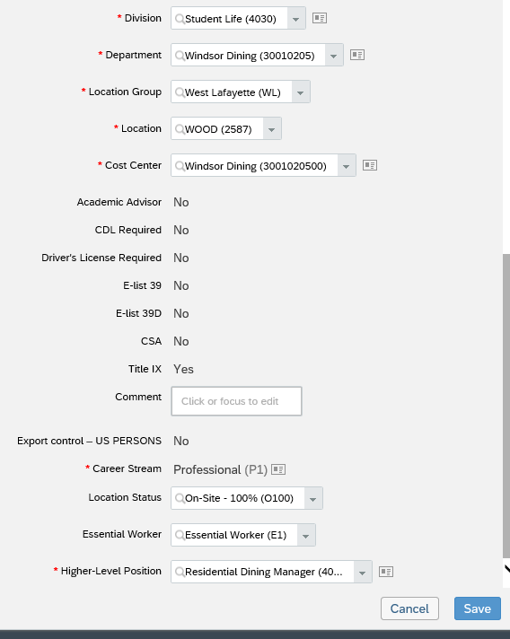
HR Admin – Position will receive notification via workflow that the position is ready to review and approve; Initiator will be notified of action taken by HR Admin – Position.

